Ict news brain computer interface

New peripherals are constantly appearing in technology one of thease if a BCI or brain computer interface that map neural processes and learns them for example say this was the thought patter for up [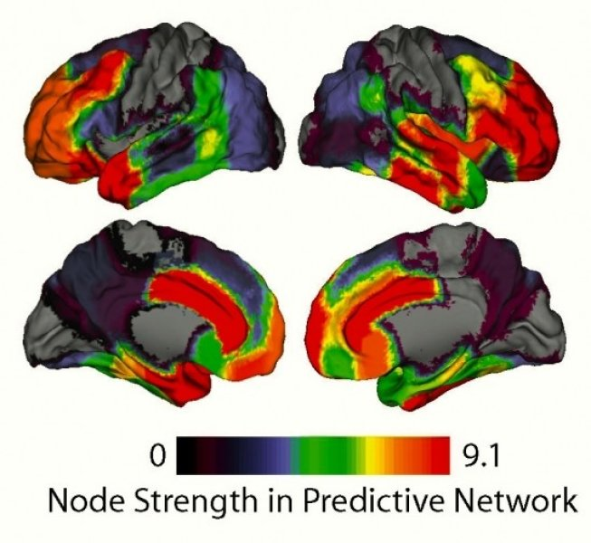](http://www.sciencedaily.com/releases/2015/04/150406121348.htm)

The computer would ask you to think up repeatedly to calibrate it when it can recognize this when you brain activity matches this the mouse cursor will move up this has infinite uses and has been used to give paralyzed people use of electric arms witch allows them to have use of a limb that they can use for eating among many other things this technology shows unlimited potential and appolactoin and for around $300 you can buy one designed for gaming.